**EX : 06 REG.NO:210701276**

**IMPORT A JSON FILE FROM THE COMMAND LINE.**

**APPLY THE FOLLOWING ACTIONS WITH THE DATA,**

**PRESENT IN THE JSON FILE WHERE PROJECTION, AGGREGATION, REMOVE, COUNT, SKIP & SORT.**

**Step 1:** Create a json file named “data.json” using the command

**$nano data.json**

Enter some data in the json file.

[

{ “name”: “Alice”, “age”: 25, “city”: New York” },

{“name”: “Bob”, “age”: 30, “city”: “Los Angeles” },

{“name”: “Charlie”, “age”: 35, “city”: “Chicago” },

{“name”: “David”, “age”: 40, “city”: “Houston” },

]

Now, while projecting the data, we enter the command $jq ‘[.[] | {name,age}]’ data.json to display a specific values.

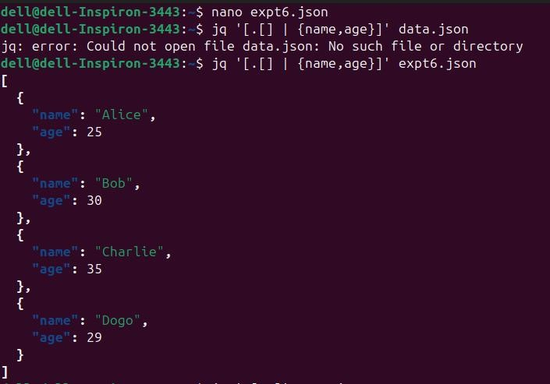

**Step 2:** Using the command $jq ‘[.[] | .age] | add / length’ data.json we get the aggregate value of the data.

**Step 3:** Using the command $jq ‘map(del(.city))’ data.json we remove some specified values of the data.

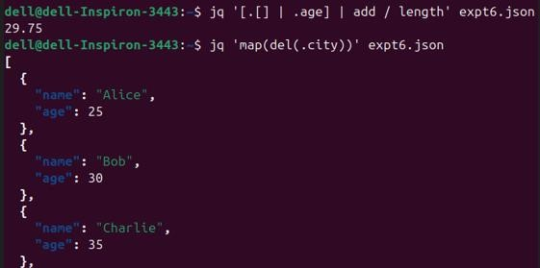

**Step 4: Using** the command $jq ‘length’ data.json we get the total count of the data.

**Step 5:** Using the command $jq ‘.[0:2]’ data.json we assign the limit of the data to be displayed.

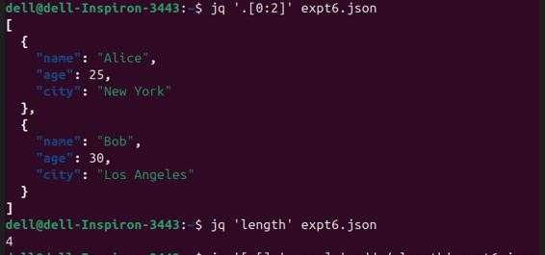

**Step 6:** Using the command $jq ‘.[2:]’ data.json , it skips some of the data and display the remaining data.

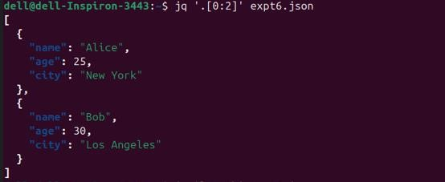

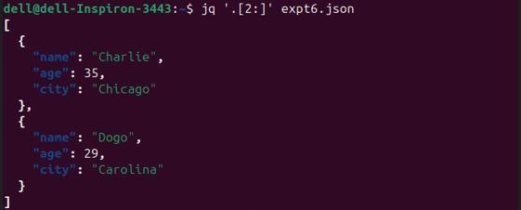

**Step 7:** Using the command $jq ‘sort_by(.age)’ data.json , it sorts the data in a specified criteria.

